

**Internet Technology**

**Practicals**

**To : Dr. Kamlesh Raghuvanshi**

**By : Avinash Gautam**

**Exam Roll No. : 20020570009**

**College Roll No. : 20201407**

**Q.1.** Display your systems IP Address, Subnet mask using ipconfig, and find out the

network address and the maximum number of systems possible on your

network and range of IP addresses available to these systems.

**Q.2.** With help of ping, check if you are connected to other systems of your

network and find the route to connect to that system using tracert. List all

the processes which are using ports for TCP protocol.

**OUTPUTS**

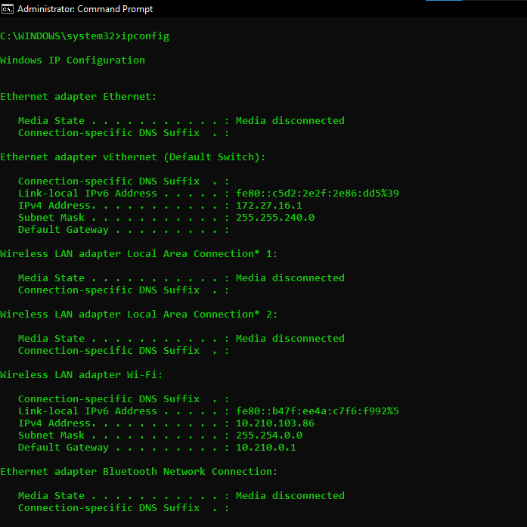

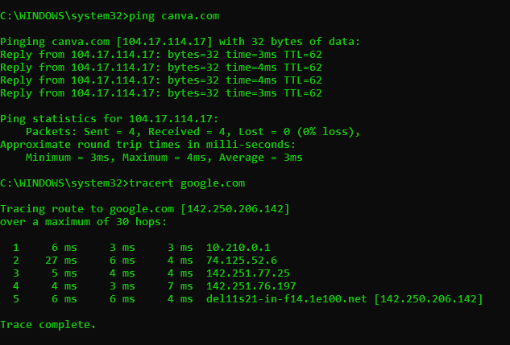

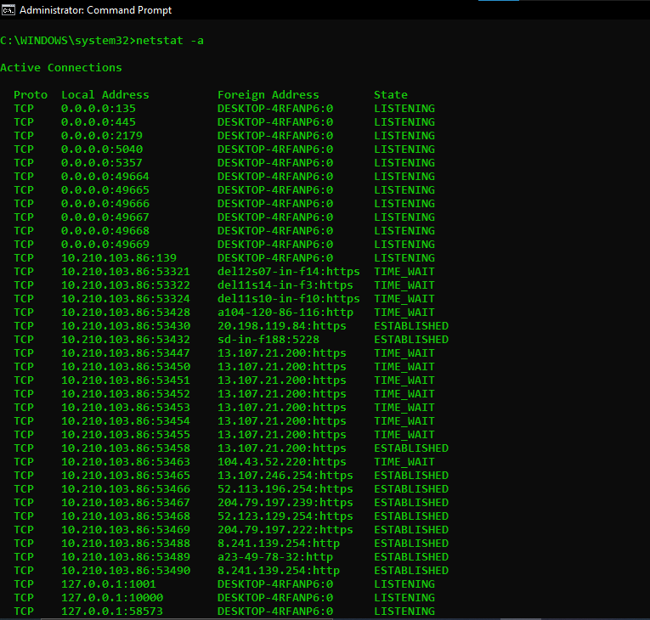

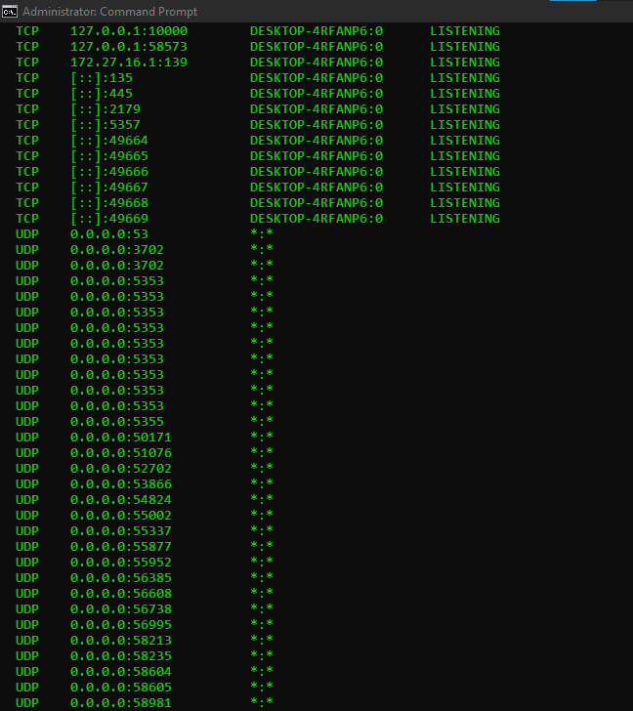

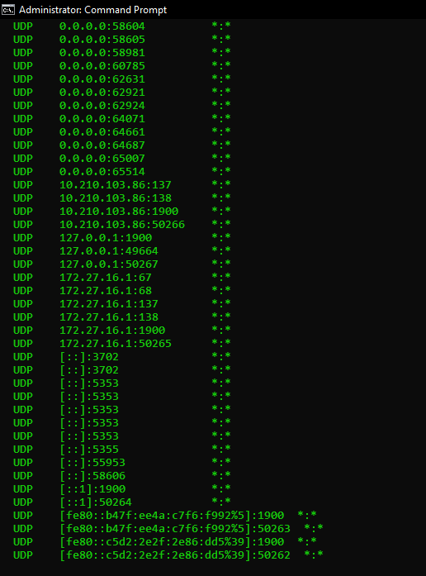

**Q.3.** Create an HTML page that shows information about you, your course,

hobbies, address, and your plans. Use CSS for styling of HTML page so that

it looks nice.

**Code :**

<!DOCTYPE html>

<html lang="en">

<head>

<meta charset="UTF-8" />

<meta http-equiv="X-UA-Compatible" content="IE=edge" />

<meta name="viewport" content="width=device-width, initial-scale=1.0" />

<title>About me</title>

<link rel="stylesheet" href="./Q3_index.css" />

</head>

<body>

<header class="tophead">

<p class="tophead-intro">Hello People, this is</p>

<h1 class="tophead-heading GradientText">Nitish Kumar</h1>

</header>

<section class="about-section">

<h1>About me</h1>

<p>

I'm a final year student of Bsc (Hons.) Computer Science at Ramanujan College, University of Delhi.

</p>

</section>

<section class="hobbies-section">

<h1>My Hobbies</h1>

<ul>

<li> Reading Books </li>

<li> Learn about Psychology & Neurological behaviour </li>

<li> Watching Movies & Anime </li>

<li> Gardening </li>

</ul>

</section>

<section class="course-section">

<h1>My Course</h1>

<p>

<br>Things that I have learnt so far:

<div class="course-list">

<ul>

<li>C++ &emsp;&ensp; &emsp;

<progress value="50" max="100">

</progress></li>

<li>Java &emsp;&nbsp;&emsp;

<progress value="30" max="100">

</progress> </li>

<li>DSA &emsp;&nbsp;&emsp;

<progress value="40" max="100">

</progress></li>

<li>Python &emsp;&nbsp;

<progress value="50" max="100">

</progress></li>

<li>R &emsp; &emsp; &emsp;

<progress value="40" max="100">

</progress></li>

</ul>

</div>

</p>

</section>

<section class="plan-section">

<h1>My Plans</h1>

<p>Nothing !!! &#x1F61C;</p>

</section>

<footer class="content-footer">

<p>Follow for more updates:</p>

<ul class="social">

<li>

<a class="css-is-deranged" href="#">

Linkedin

</a>

</li>

<li>

<a class="css-is-deranged" href="#">

Instagram

</a>

</li>

<li>

<a class="css-is-deranged" href="#">

GitHub

</a>

</li>

</ul>

</footer>

</body>

</html>

CSS:

.GradientText{

background: linear-gradient(to left, indigo, rgb(223, 20, 20), rgb(20, 240, 42));

-webkit-background-clip: text;

-webkit-border-image: auto;

-webkit-text-fill-color: transparent;

}

.GradientText:hover{

background: linear-gradient(to bottom right, #22f13ad9, #712cbbd9, #f46e07);

-webkit-background-clip: text;

-webkit-border-image: auto;

-webkit-text-fill-color: transparent;

}

body {

color: #902222;

font-size: 1em;

font-family: "Open Sans", "Helvetica Neue", sans-serif;

}

.tophead-intro {

margin-bottom: 0.1em;

font-family: "Gentium Book Basic", Georgia, serif;

font-size: 2em;

}

.tophead-heading {

color: #f1c863;

margin-top: -0.2em;

font-family: "Open Sans", "Helvetica Neue", sans-serif;

font-weight: bold;

font-size: 6em;

letter-spacing: -0.02em;

text-transform: uppercase;

}

.about-section,

.hobbies-section,

.course-section,

.plan-section {

max-width: 38em;

margin-left: auto;

margin-right: auto;

margin-top: 2em;

}

.about-section > p,

.hobbies-section > p,

.course-section,

.plan-section > p,

.content-footer > p {

font-weight: 300;

letter-spacing: 0.05em;

}

section > h1 {

margin-top: 2em;

}

.content-footer,

.tophead-heading,

.tophead-intro {

text-align: center;

margin-top: 2em;

}

.tophead {

display: -moz-box;

background-size: cover;

background-repeat: no-repeat;

border-radius: 10;

border: 12pt #1c9a3c;

border-style: groove;

}

.tophead-intro {

margin-bottom: 0.1em;

font-family: "Gentium Book Basic", Georgia, serif;

font-size: 2em;

}

.tophead-heading {

margin-top: -0.2em;

font-family: "Open Sans", "Helvetica Neue", sans-serif;

font-weight: bold;

font-size: 6em;

letter-spacing: -0.02em;

text-transform: uppercase;

}

.about-section > p,

.hobbies > p,

.content-footer > p {

font-weight: 300;

letter-spacing: 0.05em;

}

h2 {

font-family: "Gentium Book Basic", Georgia, serif;

font-size: 1.2em;

font-weight: bold;

}

.about-section,

.hobbies-section,

.course-section,

.plan-section {

max-width: 38em;

margin-left: auto;

margin-right: auto;

margin-top: 2em;

}

.content-footer {

margin: 50px 0;

padding: 20px 0;

text-align: center;

background-image: linear-gradient(to left top, rgb(114, 17, 183, 0.7), rgb(173, 15, 28),rgb(24, 40, 191));

border: 1px dashed black;

border-radius: 15px;

}

.social > li {

display: inline-block;

margin: 0 5px;

}

.content-footer > p {

color: #f7ede1;

}

a {

font-weight: bold;

text-decoration: none;

color: rgb(248, 244, 250);

}

a:hover{

color: chartreuse;

}

@media only screen and (max-width: 500px) {

.tophead {

padding: 3em 0;

}

.tophead-intro{

font-size: 2em;

}

.tophead-heading {

font-size: 3em;

}

.content-footer {

padding: 2em 2.5em;

}

}

.content-footer:hover{

background-image: linear-gradient(to left,red,green, yellow);

}

**OUTPUT:**

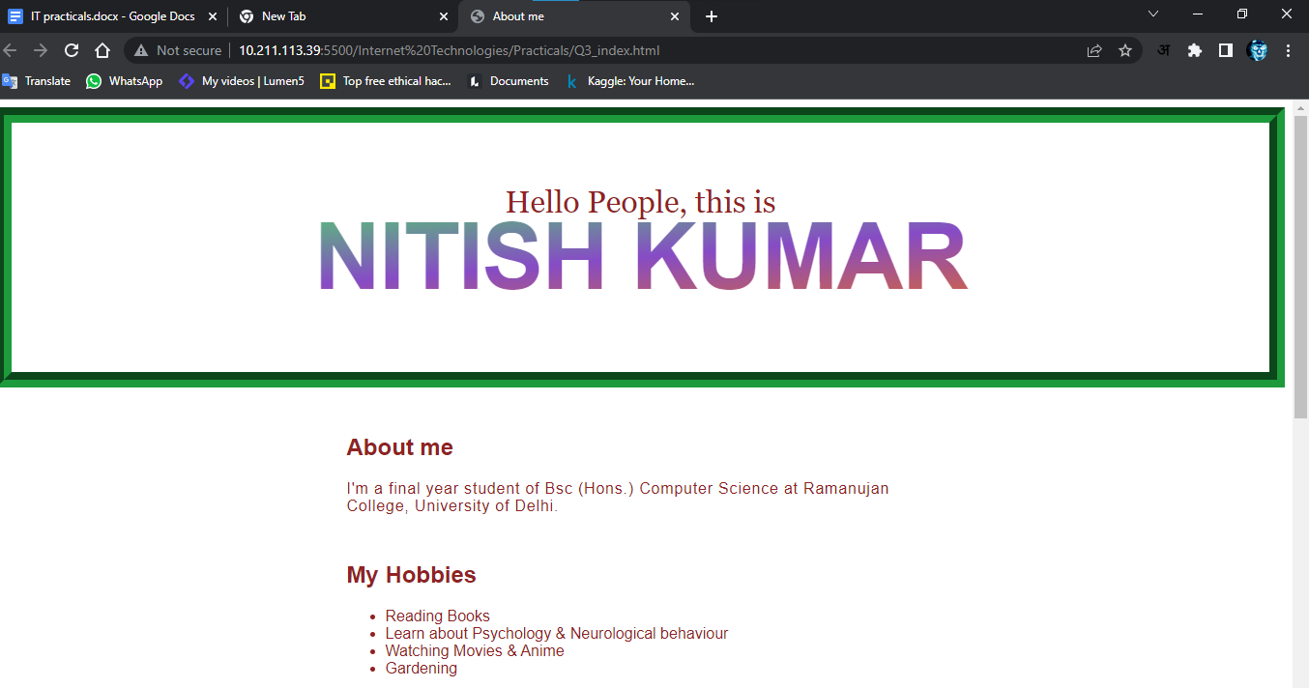

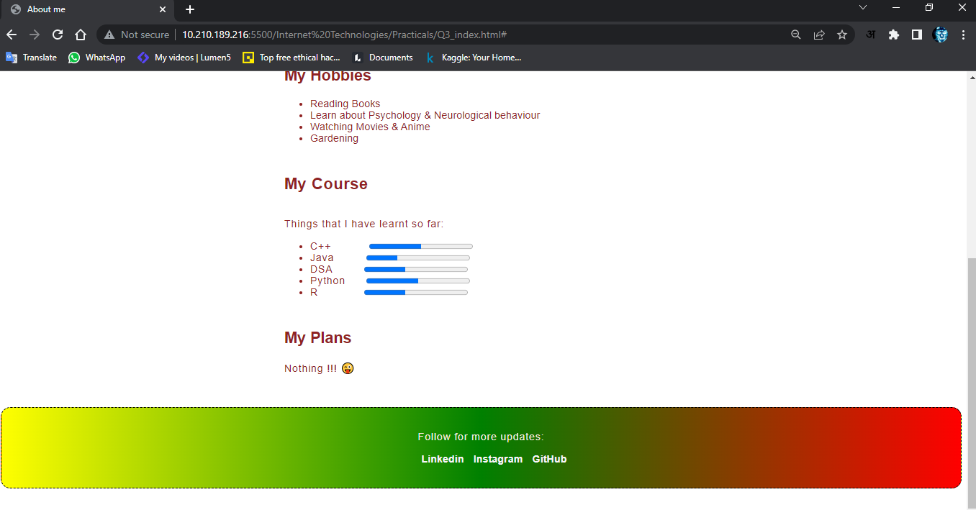

**Q.4.** Create an HTML page with the sole purpose to show multiplication tables of

2 to 10 (row-wise)created by JavaScript. Initially, the page is blank. With help

of setInterval function print a row every 5 seconds in different colors and

increasing font size.

**Code :**

<!DOCTYPE html>

<html>

<head>

  <title>Practical 4</title>

  <meta charset="utf-8">

  <style type="text/css">

    table{

*border*: 1px solid black;

*border-collapse*: collapse;

*width*: 80%;

*margin*: auto;

    }

    td,th{

*border*: 1px solid black;

*padding*: 5px;

      /* border-collapse: collapse; */

    }

    .center{

*text-align*: center;

    }

  </style>

</head>

<body>

  <h1>Printing Table from 2 to 10</h1>

  <table class="center" id="content">

  </table>

  <script type="text/javascript">

*function* getRandomColor() {

*var* letters = '0123456789ABCDEF';

*var* color = '#';

        for (*var* i = 0; i < 6; i++) {

          color += letters[Math.floor(Math.random() * 16)];

        }

      return color;

    }

*var* tbl = document.getElementById('content');

*var* number = 2;

*var* abc = setInterval(printrow,5000);

*function* printrow(){

      if (number == 10)

      {

        clearInterval(abc);

      }

*var* result = "";

      for(*var* i = 1; i<= 10; i++){

        result = result + "<td>"+ number + "*" + i + "=" + number * i+"</td>";

      }

      number++;

*var* row = document.createElement('tr');

      row.style.color= getRandomColor();

      row.style.fontSize = (number+10)+"px";

      row.innerHTML=result;

      tbl.append(row);

    }

  </script>

</body>

</html>

**OUTPUT:**

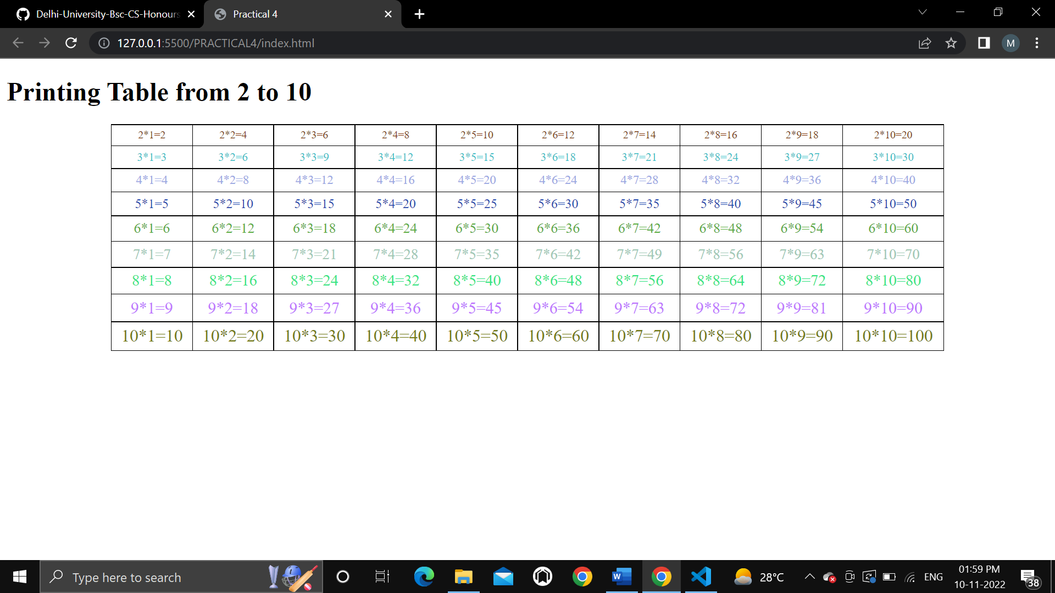

**Q.5.** Create an HTML page with a paragraph written on it and under which 9

buttons are placed in a 3X3 grid. The first row is for buttons labeled with

colors names Red, Green, and Blue, the second row with numbers 10, 20, 30,

and the third row with different font names. Click event of each of the buttons

should make the appropriate change in the style of the paragraph.

**Code**

**Html**

<!DOCTYPE html>

<html lang="en">

<head>

    <meta charset="UTF-8">

    <meta http-equiv="X-UA-Compatible" content="IE=edge">

    <meta name="viewport" content="width=device-width, initial-scale=1.0">

    <title>Grid</title>

    <link rel="stylesheet" href="practical4b.css">

</head>

<body>

    <p> Lorem, ipsum dolor sit amet consectetur adipisicing elit. Delectus impedit fuga optio. Eveniet eligendi saepe ad inventore, magnam repellendus maiores nobis ipsum accusantium modi enim eos quasi ex fugit. Laboriosam! Lorem ipsum dolor sit amet consectetur adipisicing elit. Officia eum esse suscipit cumque natus repellat ea distinctio omnis, quod quasi minima facilis adipisci quis laboriosam ab quisquam perferendis error! Libero? Lorem ipsum dolor, sit amet consectetur adipisicing elit. Illo, perspiciatis vel exercitationem pariatur est repellendus amet, cupiditate illum vitae aspernatur reprehenderit iure quis, error itaque dolore molestiae qui quod a? Lorem ipsum dolor sit amet consectetur adipisicing elit. Aut delectus maxime cupiditate consectetur rerum aliquid. Ex ullam natus autem vitae, dignissimos iure id nulla, vel vero quisquam magni necessitatibus magnam. </p>

    <table>

        <tr>

            <td><button class="btn1">Red</button></td>

            <td class="vertical">

<button class="btn2">Green</button>

</td>

            <td><button class="btn3">Blue</button></td>

        </tr>

        <tr>

            <td class="horizontal">

<button class="btn4">10</button>

</td>

            <td class="vertical horizontal">

<button class="btn5">20</button>

</td>

            <td class="horizontal">

<button class="btn6">30</button>

</td>

        </tr>

        <tr>

            <td><button class="btn7">Courier New</button></td>

            <td class="vertical">

<button class="btn8">Franklin Gothic Medium</button>

</td>

            <td><button class="btn9">Lucida Sans</button></td>

        </tr>

    </table>

    <script src="practical4b.js"></script>

</body>

</html>

**CSS code**

td, button {

*width*: 100px;

*height*: 100px;

*margin*: 0 auto;

}

.vertical {

*border-left*: 1px solid black;

*border-right*: 1px solid black;

}

.horizontal {

*border-top*: 1px solid black;

*border-bottom*: 1px solid black;

}

table {

*margin*: auto;

}

**Javascript code**

*const* button1 = document.querySelector('.btn1');

*const* button2 = document.querySelector('.btn2');

*const* button3 = document.querySelector('.btn3');

*const* button4 = document.querySelector('.btn4');

*const* button5 = document.querySelector('.btn5');

*const* button6 = document.querySelector('.btn6');

*const* button7 = document.querySelector('.btn7');

*const* button8 = document.querySelector('.btn8');

*const* button9 = document.querySelector('.btn9');

button1.addEventListener('click', *function* () {

    document.querySelector('p').style.color = 'red';

})

button2.addEventListener('click', *function* () {

    document.querySelector('p').style.color = 'green';

})

button3.addEventListener('click', *function* () {

    document.querySelector('p').style.color = 'blue';

})

button4.addEventListener('click', *function* () {

    document.querySelector('p').style.fontSize = '10px';

})

button5.addEventListener('click', *function* () {

    document.querySelector('p').style.fontSize = '20px';

})

button6.addEventListener('click', *function* () {

    document.querySelector('p').style.fontSize = '30px';

})

button7.addEventListener('click', *function* () {

    document.querySelector('p').style.fontFamily = 'Courier New', Courier, monospace;

})

button8.addEventListener('click', *function* () {

    document.querySelector('p').style.fontFamily = 'Franklin Gothic Medium', 'Arial Narrow', Arial, sans - serif;

})

button9.addEventListener('click', *function* () {

    document.querySelector('p').style.fontFamily = 'Lucida Sans', 'Lucida Sans Regular', 'Lucida Grande', 'Lucida Sans Unicode', Geneva, Verdana, sans - serif;

})

**Output**

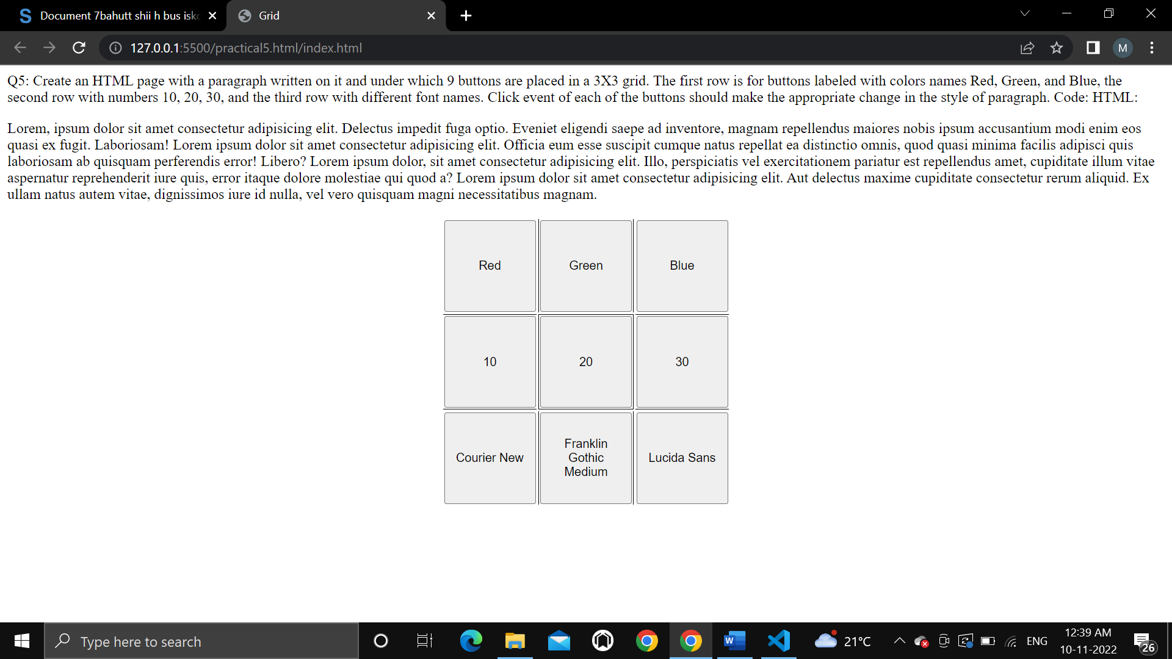

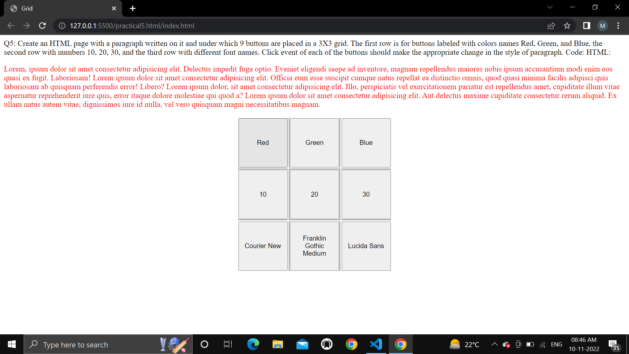

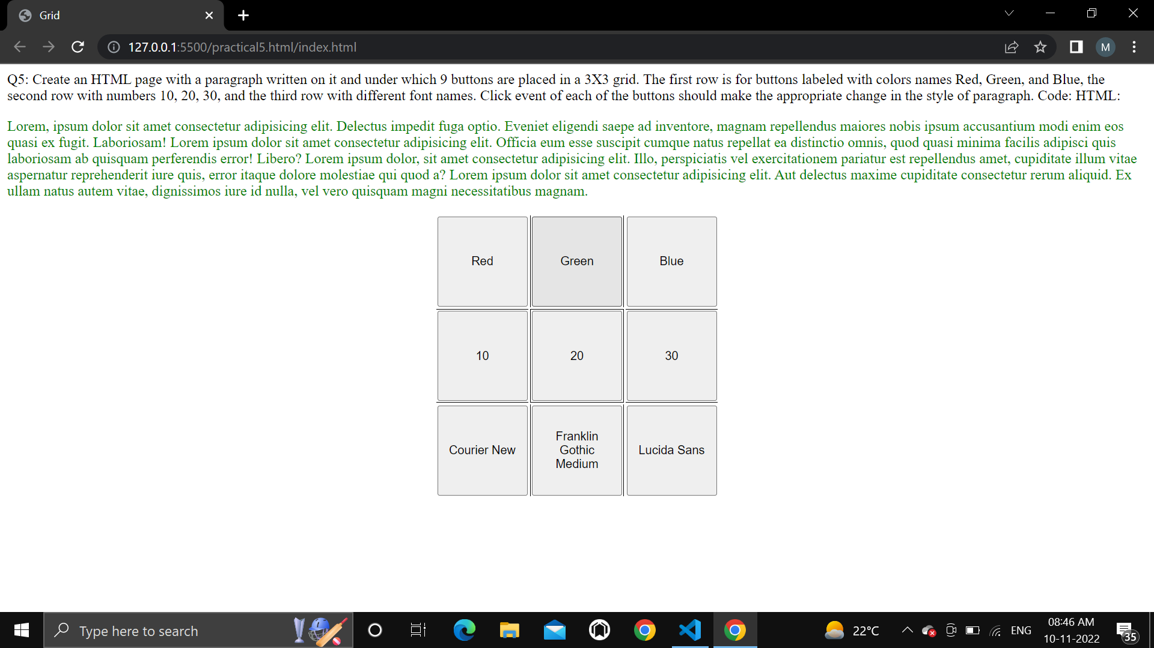

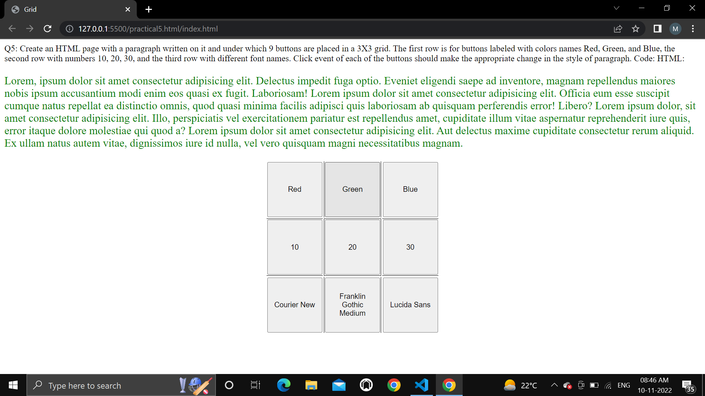

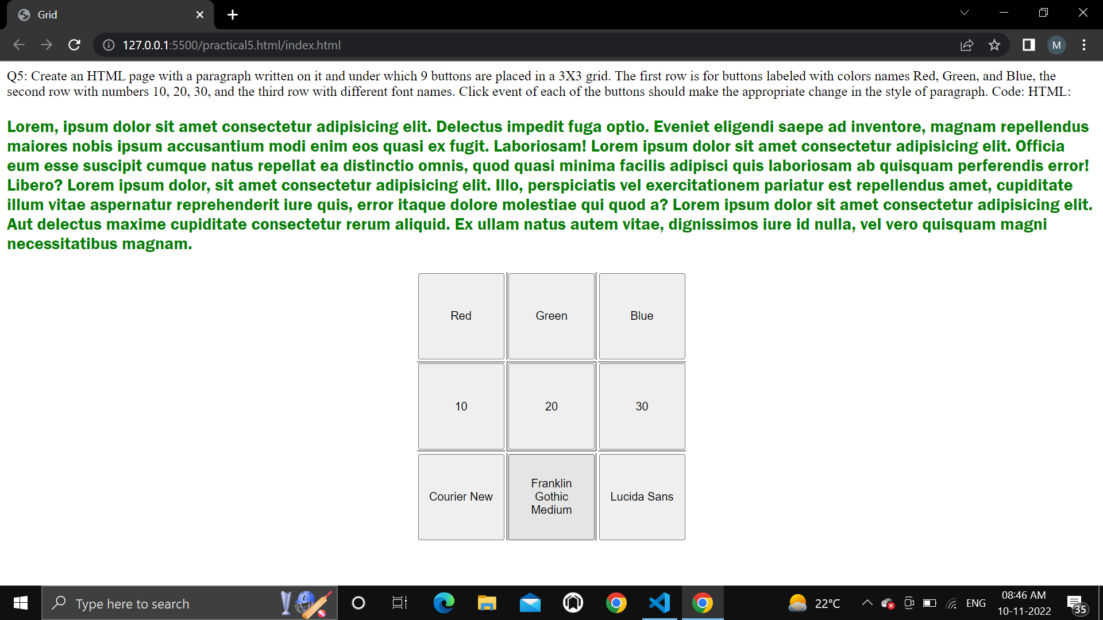

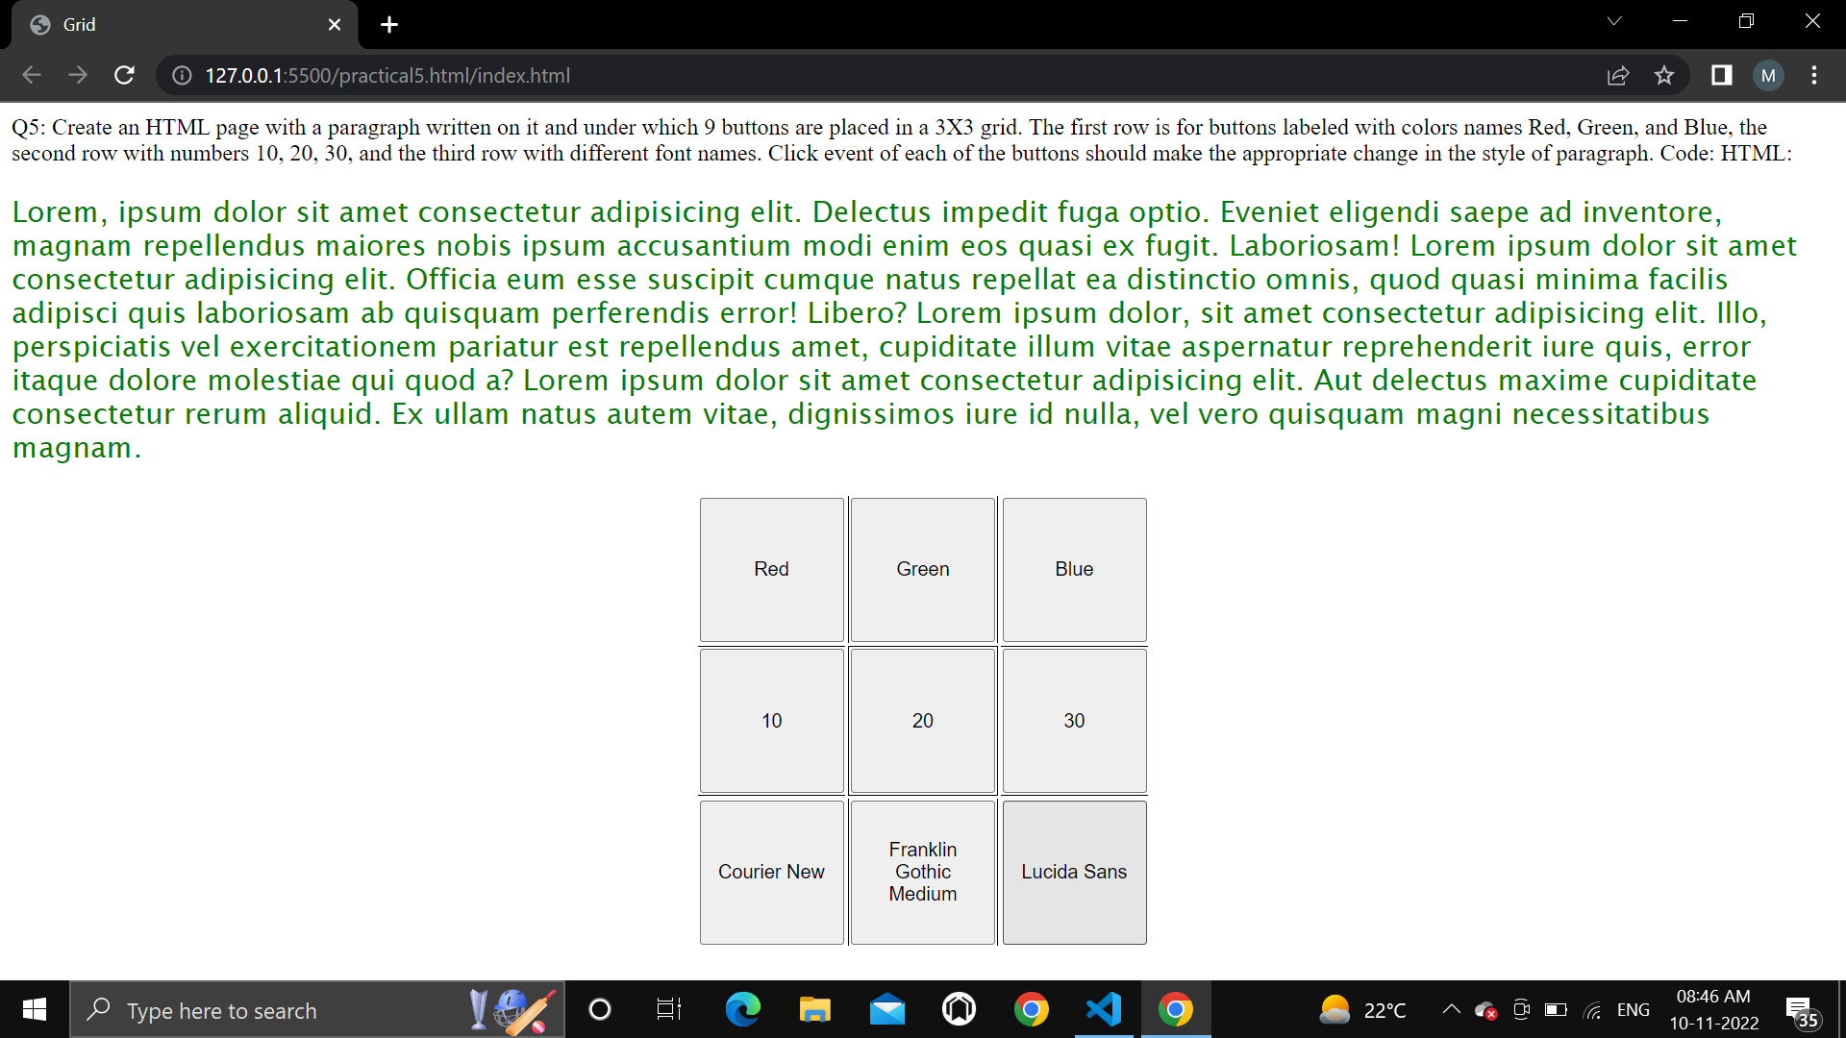

**Q.6.** Create a form that takes data about a pet. The form must be well designed and

should accept the pet’s name, age, weight, type, and what it likes most. At the

submission of this form create a Pet object in JavaScript filled with these

values and log that object and equivalent JSON on the console.

**CODE:**

<!DOCTYPE html>

<html>

<head>

    <meta charset="utf-8">

    <title>Practical 6</title>

    <style type="text/css">

        .container{

*width*: 60%;

*margin*: auto;

*border*: 1px solid black;

*border-radius*: 8px;

*padding*: 50px;

        }

        .btn-submit{

*border-radius*: 5px;

*color*: white;

*background*: greenyellow;

*font-weight*: bold;

*font-size*: 1rem;

*margin*: 20px;

        }

        @media(*width*<=575){

            .container{

*width*: 84%;

            }

        }

    </style>

</head>

<body>

    <div class="container">

        <h1>Pet's Information</h1>

        <hr>

        <label for="name">Pet's Name: </label>

        <input type="text" name="name"><br><br>

        <label for="age">Age: </label>

        <input type="number" name="age">

        <label for="weight">Weight: </label>

        <input type="number" name="weight" class=""><br><br>

        <label for="type">Pet type: </label>

        <input type="text" name="type"><br><br>

        <label for="likes">Likes: </label>

        <input type="text" name="likes"><br>

        <button class="btn-submit" onclick="display()">Submit</button>

    </div>

    <script type="text/javascript">

*function* display(){

*var* pet = {};

*var* input_fields = document.getElementsByTagName('input');

            for (*var* i = 0; i < input_fields.length; i++) {

                pet[input_fields[i].name] = input_fields[i].value;

            }

            console.log(pet);

        }

    </script>

</body>

</html>

**OUTPUT:**

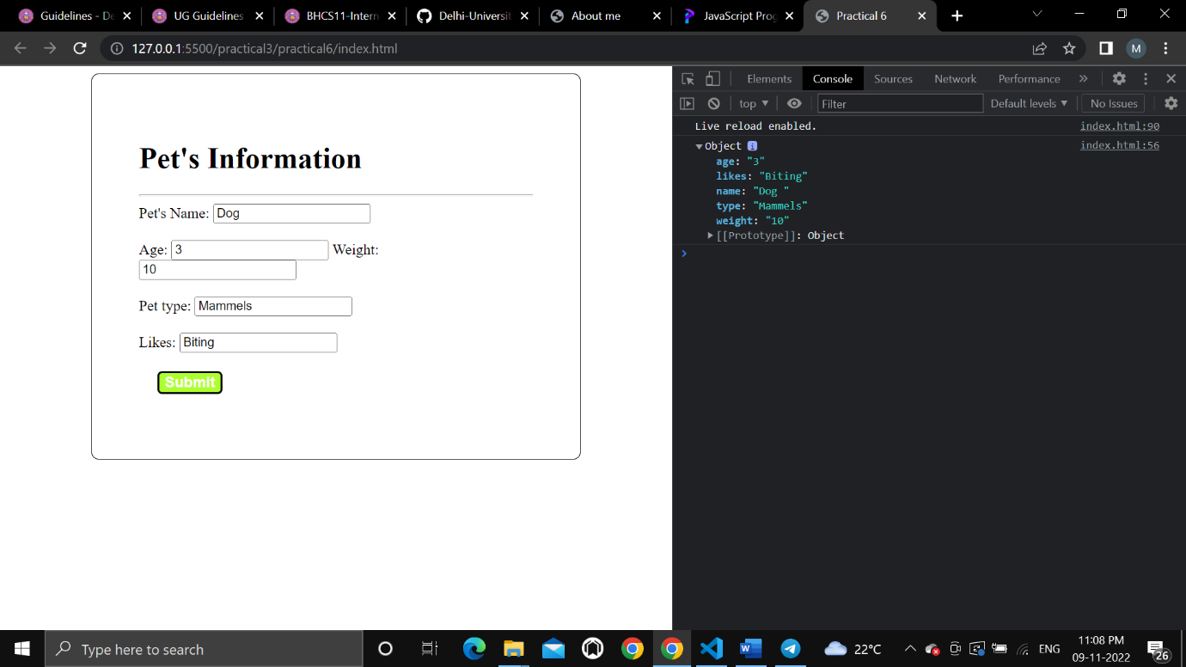

**Q.7.** Store JSON data of few pets that you created in previous practical in a JSON

file (copy from console output of previous program to a .json file). Using

AJAX, load data from the file and display it in a presentable way using

HTML and CSS.

**Code:**

**<!DOCTYPE html>**

**<html lang = "en">**

**<head>**

**<meta charset="utf-8">**

**<meta name="viewport" content="width=device-width, initial-scale=1.0" />**

**<title>Practical 7</title>**

**<style type="text/css">**

**#pet-data{**

**border: 1px solid black;**

**border-radius: 10px;**

**border-collapse: collapse;**

**}**

**td{**

**border: 1px solid black;**

**border-collapse: collapse;**

**}**

**#btn-fetch{**

**margin-top: 20px;**

**font-size: 24px;**

**font-weight: bold;**

**background-color: black;**

**color: white;**

**border-radius: 8px;**

**}**

**</style>**

**</head>**

**<body>**

**<div id="content">**

**</div>**

**<button id="btn-fetch">Fetch Data</button>**

**<script src="https://ajax.googleapis.com/ajax/libs/jquery/3.5.1/jquery.min.js"></script>**

**<script type="text/javascript">**

**var btnFetch = document.getElementById('btn-fetch');**

**var content = document.getElementById('content');**

**btnFetch.addEventListener('click', ()=>{**

**const xhr = new XMLHttpRequest();**

**xhr.open("GET","./pet.json",true);**

**xhr.onload = ()=>{**

**console.log(xhr.responseText);**

**renderHtml(JSON.parse(xhr.responseText));**

**}**

**xhr.send();**

**});**

**function renderHtml(data){**

**content.innerHTML = "";**

**for (var i = 0; i <= data.length; i++) {**

**let p = document.createElement('p');**

**let htmlpart = "";**

**htmlpart += data[i].name+" is a "+data[i].type+" with age "+data[i].age+" years and weight "+data[i].weight+"kg and likes "+data[i].likes;**

**p.innerHTML = htmlpart;**

**content.append(p);**

**// console.log(tr);**

**htmlpart="";**

**}**

**}**

**</script>**

**</body>**

**</html>**

**Output:**

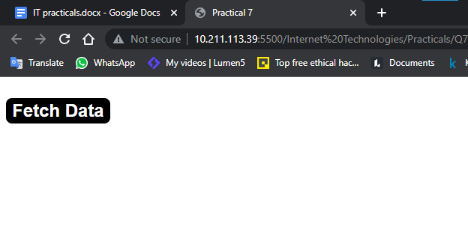

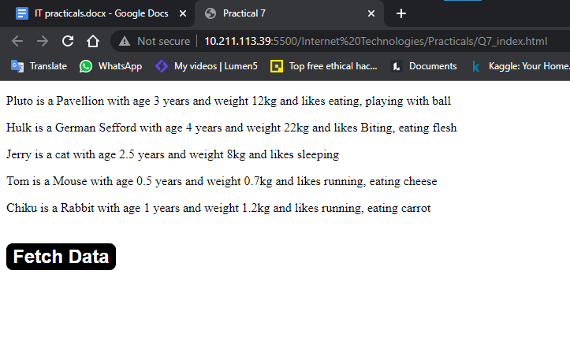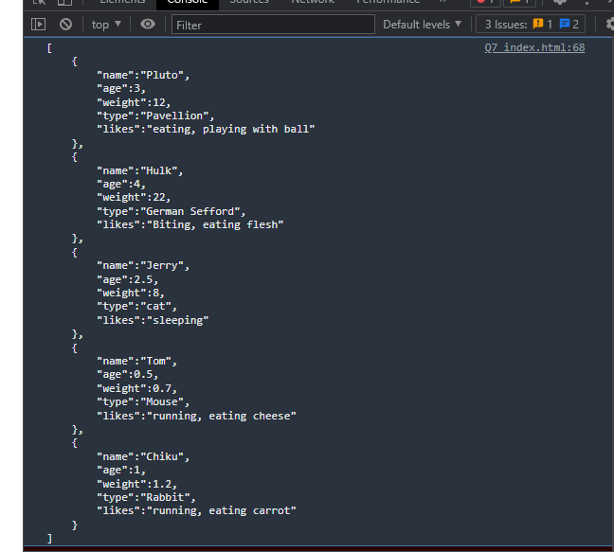

**Q.8.** Create a plain HTML page for B.Sc. Hons CS course, mentioning details like

fee, eligibility criteria, papers with names and credits, and future possibilities

after the course. A button for styling should be there at the bottom of the

page. On clicking on this button JavaScript should redesign the complete page

using jQuery in a nice presentable way.

**Code:**

<!DOCTYPE html>

<html>

<head>

    <meta charset="utf-8">

    <title>Practical 8</title>

    <style type="text/css">

        .container {

*width*: 70%;

*margin*: auto;

*align-items*: center;

*background-color*: #D9CAB3;

*padding-bottom*: 10px;

        }

        .info-table {

*width*: 80%;

*margin*: auto;

*border*: 3px solid black;

*border-collapse*: collapse;

*margin-top*: 2%;

*margin-bottom*: 2%;

        }

        .table-row {

*width*: 100%;

*margin*: auto;

        }

        .table-data {

*width*: 50%;

*border*: 2px solid white;

*border-collapse*: collapse;

        }

    </style>

</head>

<body>

    <div>

        <h1 class="heading">Bsc Hons Computer Science</h1>

        <table>

            <tr>

                <td>Fee</td>

                <td>33000</td>

            </tr>

            <tr>

                <td>Eligibility Criteria</td>

                <td>12th Pass</td>

            </tr>

            <tr>

                <td>Subjects and credit scores</td>

                <td>

                    <table>

                        <tr>

                            <th>Subject</th>

                            <th>Credit score</th>

                        </tr>

                        <tr>

                            <td>IT</td>

                            <td>6</td>

                        </tr>

                        <tr>

                            <td>Toc</td>

                            <td>6</td>

                        </tr>

                        <tr>

                            <td>DAV/System Programming</td>

                            <td>4</td>

                        </tr>

                        <tr>

                            <td>DIP/Micro</td>

                            <td>4</td>

                        </tr>

                    </table>

                </td>

            </tr>

            <tr>

                <td>Future Opportunities</td>

                <td>infinite Opportunities but its totally depend on you and your skill</td>

            </tr>

        </table>

    </div>

    <button id="btn-style">

        Style Page

    </button>

    <script src="<https://ajax.googleapis.com/ajax/libs/jquery/3.5.1/jquery.min.js>">

</script>

    <script type="text/javascript">

        $(document).ready(*function* () {

            $('#btn-style').click(*function* () {

                $("div").addClass('container');

                $("table").addClass('info-table');

                $("tr").addClass('table-row');

                $("td").addClass('table-data');

                $(".heading").css({

                    "textAlign": 'center'

                });

            });

        });

    </script>

</body>

</html>

**Output:**

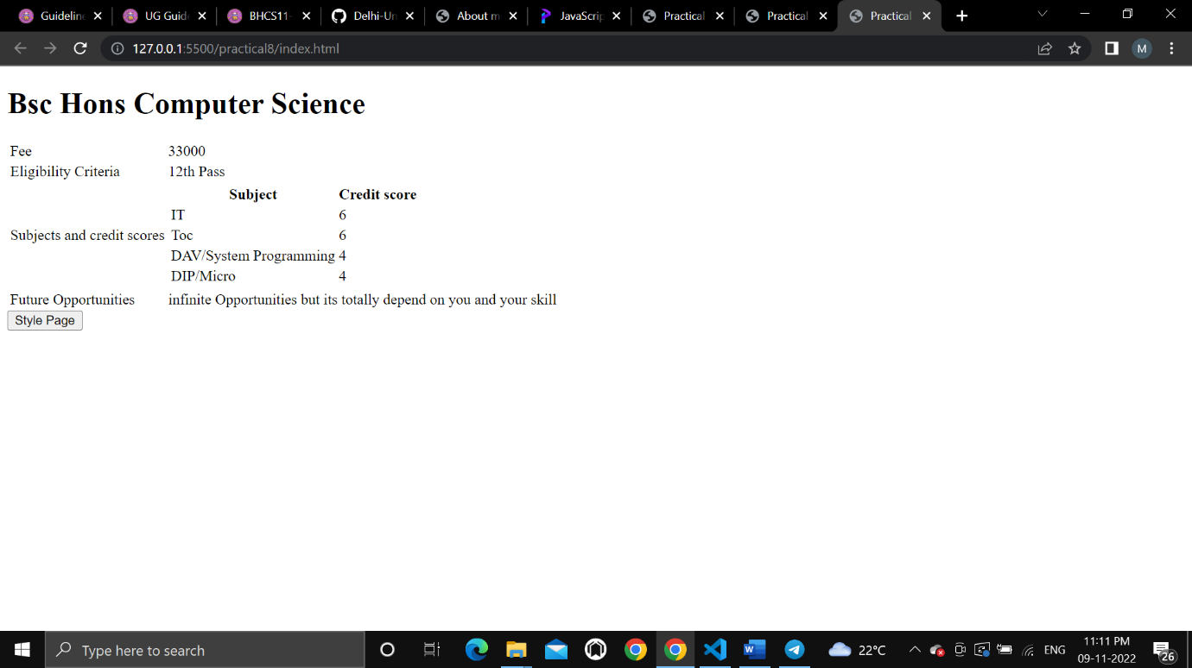

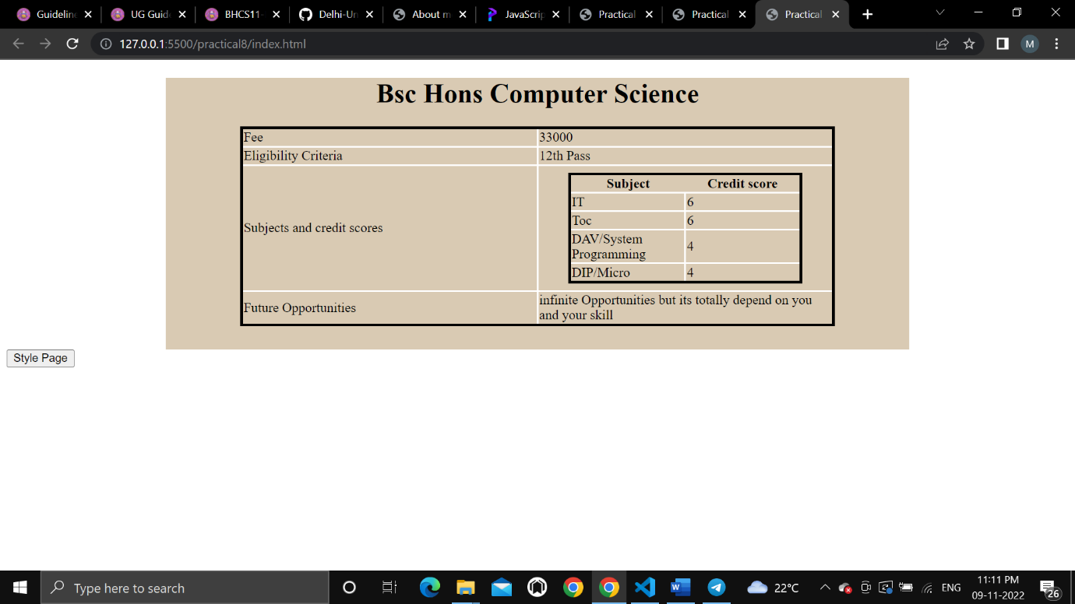

**Q.9.** Create an HTML page for an image gallery which shows the use of

BOOTSTRAP to rearrange and resize its contents on resizing the browser.

**Code:**

<!DOCTYPE html>

<html>

<head>

    <meta charset="utf-8">

    <meta name="viewport" content="width=device-width, initial-scale=1">

    <link

rel="stylesheet"

href="https://maxcdn.bootstrapcdn.com/bootstrap/3.4.1/css/bootstrap.min.css">

    <title>Practical 9</title>

    <style type="text/css">

        /*img{

            margin: 20px;

        }*/

    </style>

</head>

<body>

    <div class="jumbotron text-center">

      <h1>IMAGE GALLERY</h1>

      <p>Responsive Image gallery using bootstrap.</p>

    </div>

    <div class="container">

        <img class="col-sm-4" src="https://picsum.photos/200/"></img>

        <img class="col-sm-4" src="https://picsum.photos/200/"></img>

        <img class="col-sm-4" src="https://picsum.photos/200/"></img>

        <img class="col-sm-4" src="https://picsum.photos/200/"></img>

        <img class="col-sm-4" src="https://picsum.photos/200/"></img>

        <img class="col-sm-4" src="https://picsum.photos/200/"></img>

    </div>

    <script src="<https://ajax.googleapis.com/ajax/libs/jquery/3.5.1/jquery.min.js>">

</script>

    <script

src="<https://maxcdn.bootstrapcdn.com/bootstrap/3.4.1/js/bootstrap.min.js>">

</script>

</body>

</html>

**Output:**

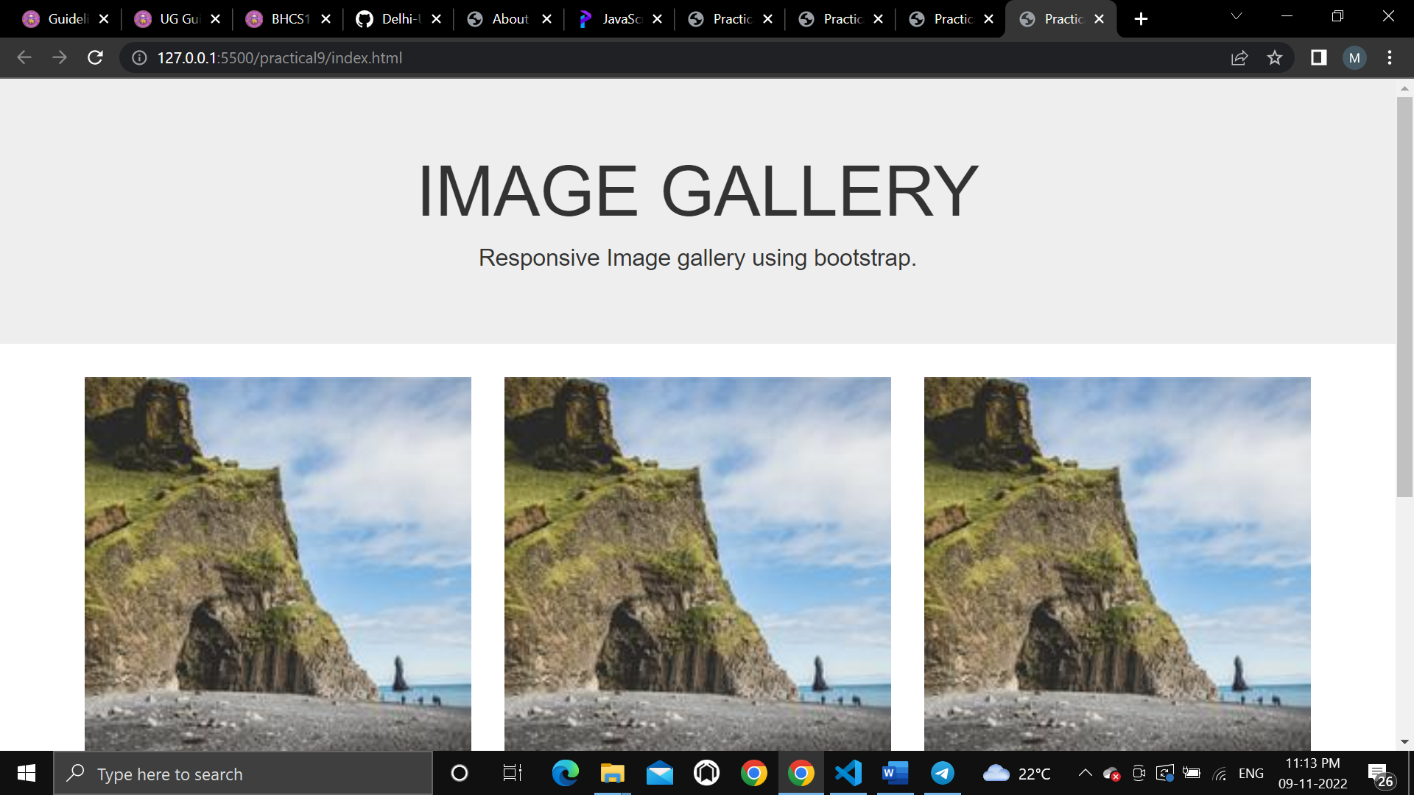

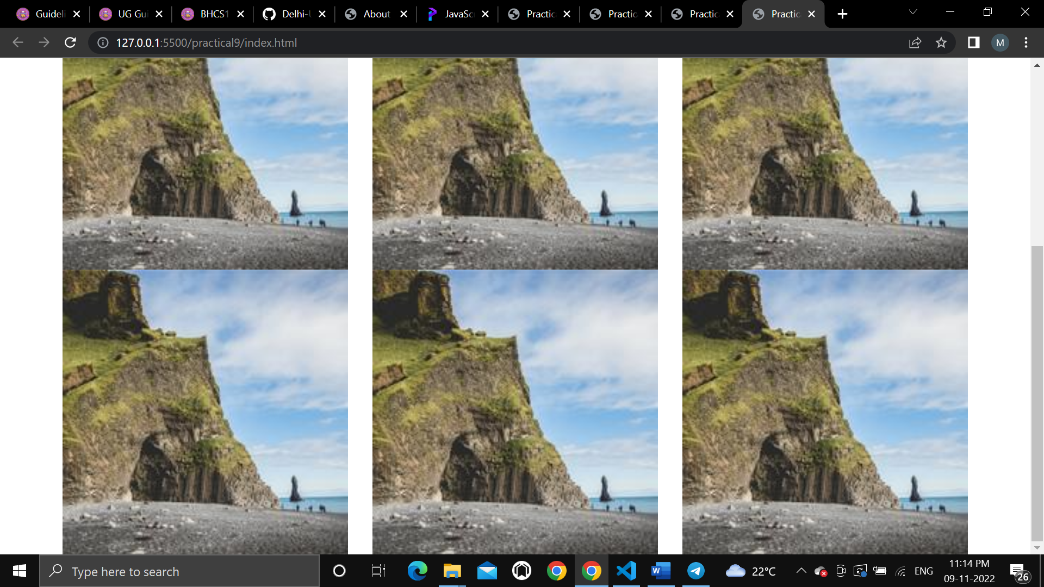

**Q.10.** Create an HTTP server using Node.js which handles requests on port 10000

or a free port beyond 10000. Modify the server in such a way that opening

localhost:10000 will display “Hello world, This is my Node.js server” on the

browser.

**Code**

*var* http = require('http');

http.createServer((*request*,*response*)*=>*{

*response*.write("Hello World, This is my Node.js server");

*response*.end();

})

.listen(10000,()*=>*console.log('server started at port 10000'));

**Output**

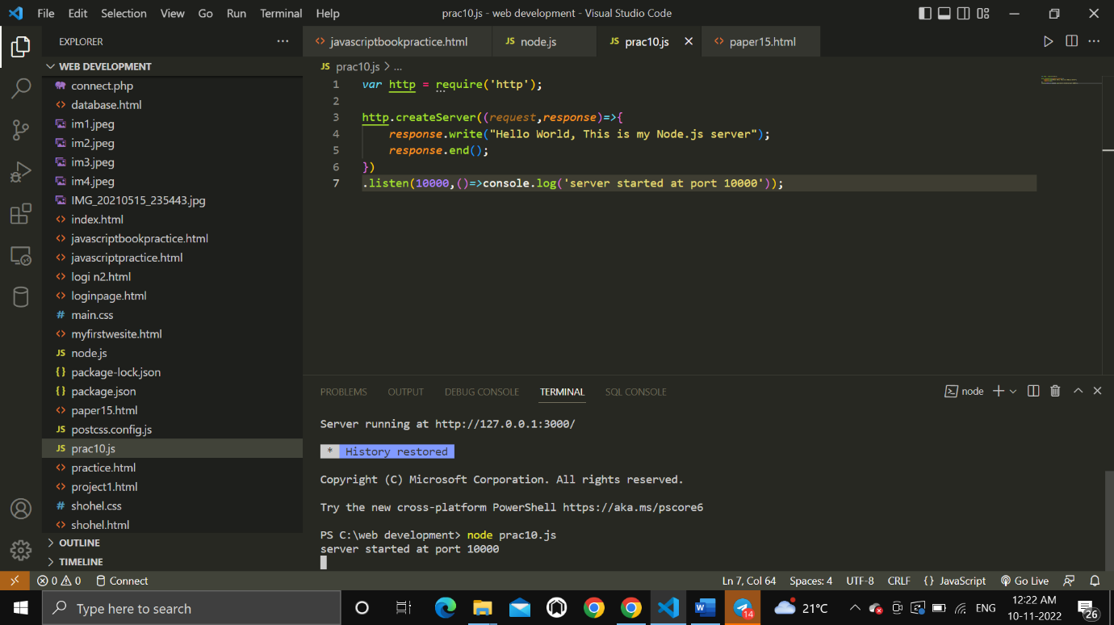

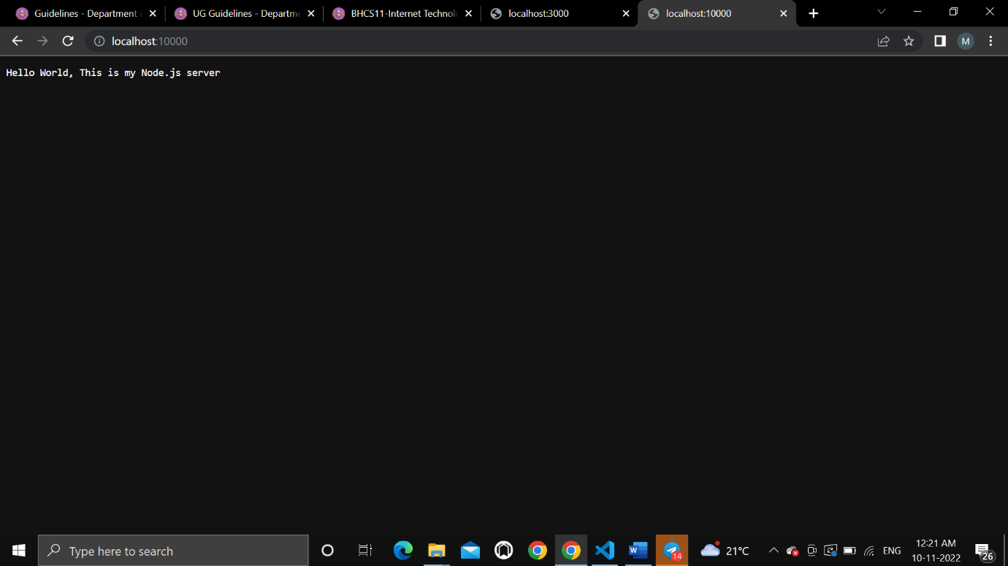

**Q.11**. Create index.html file containing two forms for SignIn and SignUp.

Submitting SignIn form should search for credentials in mysql database

using a server created in previous practical. On successful signin, a welcome

page should be displayed. Submitting the SignUp form should insert a new

entry for credentials in the mysql database using the server created in

previous practical. On successful sign up, the user should be returned back

to index.html.

**Code:**

<!DOCTYPE html>

<html lang="en">

  <head>

    <meta charset="UTF-8" />

    <meta http-equiv="X-UA-Compatible" content="IE=edge" />

    <meta name="viewport" content="width=device-width, initial-scale=1.0" />

    <title>SignIn-SignUp Form</title>

    <link rel="stylesheet" href="style.css" />

  </head>

  <body>

    <section class="container">

      <h2>SignIn Form</h2>

      <form class="form">

        <div>

          <label for="username">Username:</label>

          <input type="text" id="username" placeholder="Enter username" />

        </div>

        <div>

          <label for="password">Password:</label>

          <input type="password" id="password" placeholder="Enter password" />

        </div>

        <button class="submit-btn">Submit</button>

      </form>

    </section>

    <section class="container">

      <h2>SignUp Form</h2>

      <form class="form">

        <div>

          <label for="name">Name:</label>

          <input type="text" id="name" placeholder="Enter name" />

        </div>

        <div>

          <label for="email">E-mail:</label>

          <input type="email" id="email" placeholder="Enter e-mail" />

        </div>

        <div>

          <label for="new-username">Username:</label>

          <input

            type="text"

            class="new-username"

            placeholder="Create username"

          />

        </div>

        <div>

          <label for="new-password">Password:</label>

          <input

            type="password"

            id="new-password"

            placeholder="Enter password"

          />

        </div>

        <div>

          <label for="re-password">Password (confirm):</label>

          <input

            type="password"

            id="re-password"

            placeholder="Enter password again"

          />

        </div>

        <button class="submit-btn">Submit</button>

      </form>

    </section>

  </body>

</html>

CSS:

/*

SPACING SYSTEM (px)

2 / 4 / 8 / 12 / 16 / 24 / 32 / 48 / 64 / 80 / 96 / 128

FONT SIZE SYSTEM (px)

10 / 12 / 14 / 16 / 18 / 20 / 24 / 30 / 36 / 44 / 52 / 62 / 74 / 86 / 98

*/

/*

MAIN COLOR: #099268

GREY COLOR: #087f5b

ACCENT: #20c997, #e6fcf5

*/

* {

*margin*: 0;

*padding*: 0;

*box-sizing*: border-box;

  }

  body {

*font-family*: sans-serif;

*width*: 850px;

*margin*: 40px auto;

*display*: grid;

*grid-template-columns*: repeat(2, 1fr);

*column-gap*: 40px;

*align-items*: center;

  }

  .container {

*background-color*: #e6fcf5;

*padding*: 40px;

*border-radius*: 30px;

*box-shadow*: 0 20px 30px 0 rgb(0, 0, 0, 0.07);

  }

  .form {

*display*: grid;

*grid-template-columns*: 1fr;

*justify-items*: start;

*align-items*: center;

*row-gap*: 30px;

  }

  h2 {

*background-color*: #099268;

*display*: inline-block;

*padding*: 20px;

*border-radius*: 20px;

*color*: #e6fcf5;

*margin-bottom*: 52px;

*word-spacing*: 2px;

*letter-spacing*: 0.5px;

  }

  .submit-btn {

*font-size*: 18px;

*text-transform*: uppercase;

*background-color*: #099268;

*border*: none;

*color*: #fff;

*padding*: 10px 20px;

*border-radius*: 10px;

*align-self*: end;

*letter-spacing*: 2px;

  }

  .submit-btn:hover {

*background-color*: #087f5b;

*cursor*: pointer;

  }

  label {

*display*: inline-block;

*margin-bottom*: 8px;

*color*: #20c997;

*letter-spacing*: 0.5px;

*font-size*: 16px;

  }

  .form input {

*padding*: 10px;

*border-radius*: 10px;

*width*: 300px;

*height*: 50px;

*border*: none;

*font-size*: 18px;

  }

**Output:**

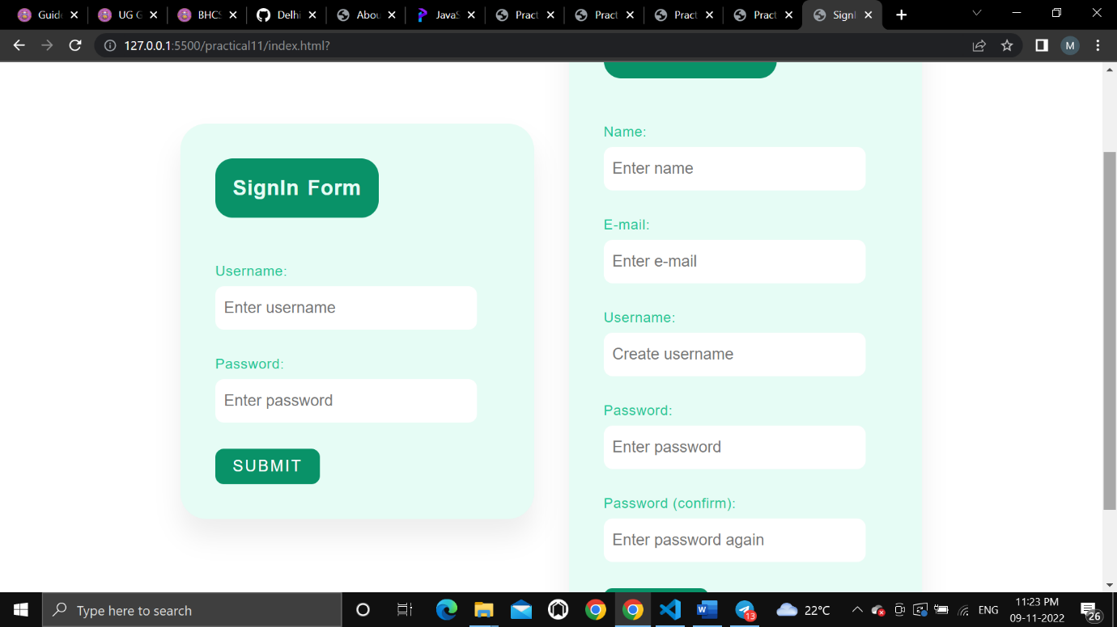

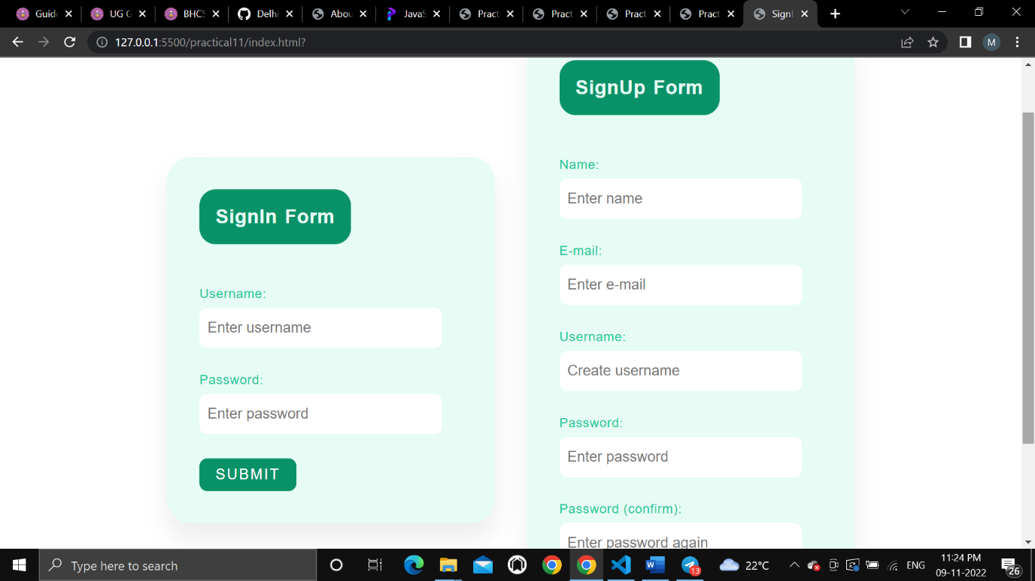

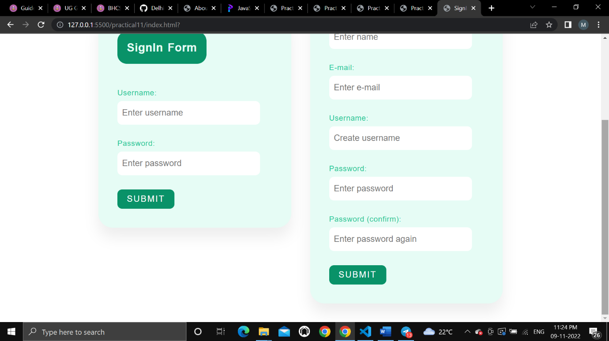

**The End**